

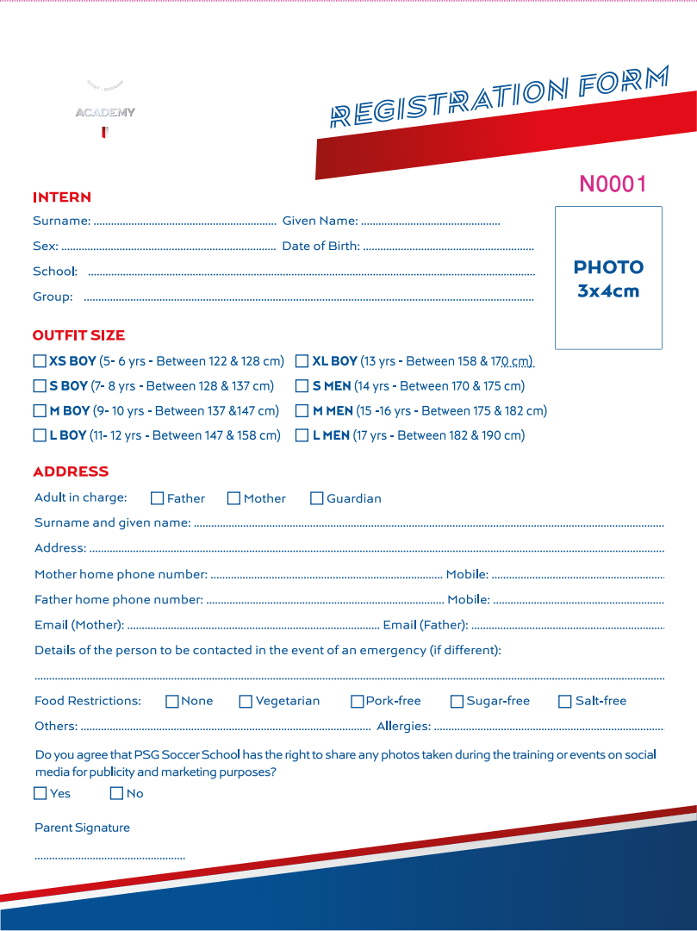**Address**：Qiantan Sports Park,735 Qiantan Avenue,Shanghai

**Phone** **numbers**：183 0196 2877

**Email**： info@psgacademychina.com